# REPORTS OF THE PATIENT

# Reports homepage:

# This is the required homepage which satisfies our business goals as you can see below. From the below homepage we can access the registered patient’s data, doctors, medical records, total quantity and cost of the medicines and appointments.

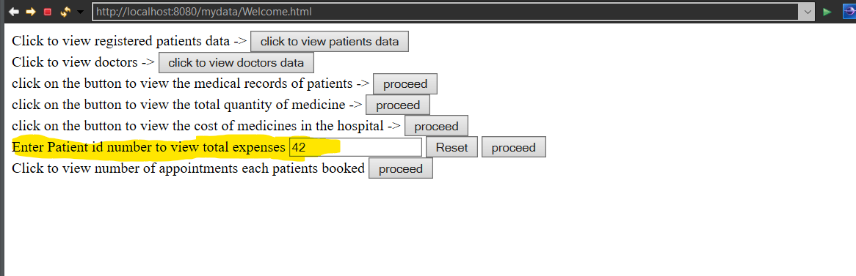

# We used dynamic queries implemented in phase 4 and retrieving the expenses and the medicine used by a particular patient till date.

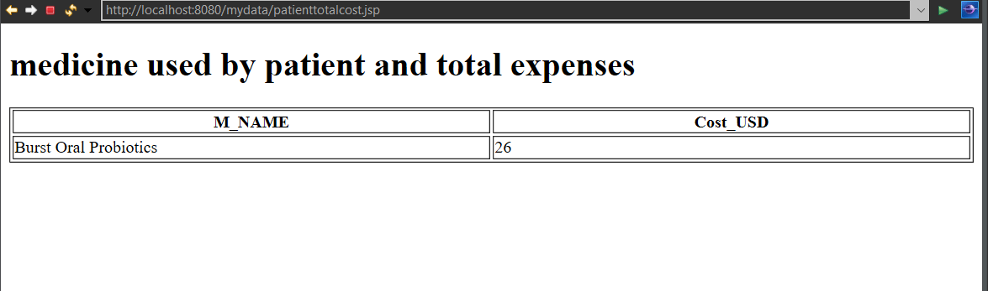These are the Id’s and contact numbers for the respective doctors in the hospital.

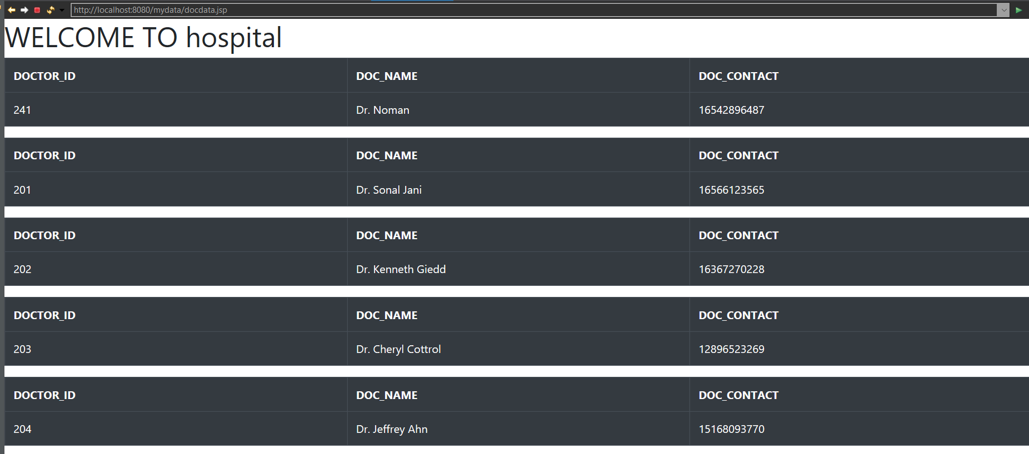

# These are the List of the medicines and their respective price in usd.

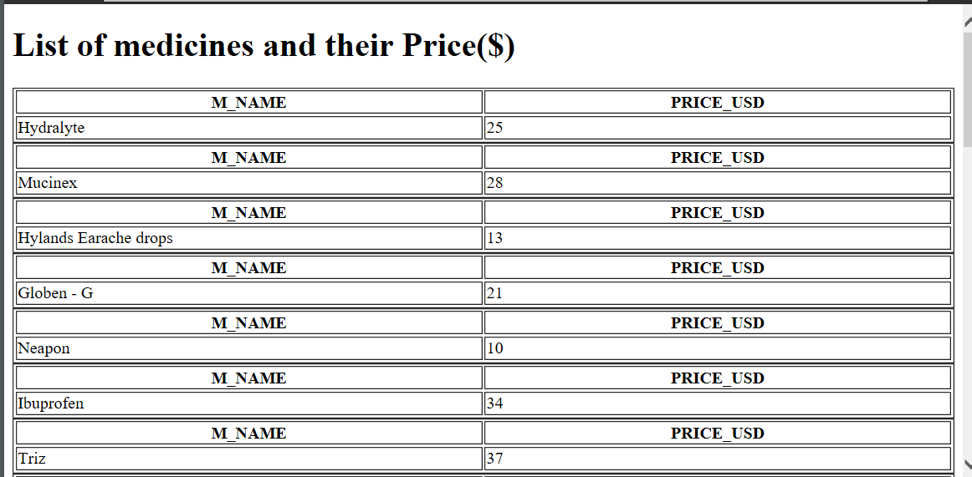

# These are the medical records of the patients in hospital which contains record id, medicine id, disease id, medicine & disease name, the diagnosis provided by the doctor includes patient, appointment, doctor ids.

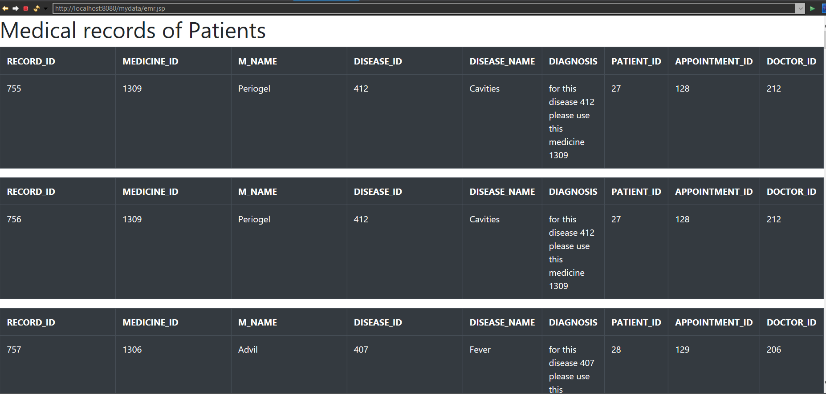

# These are the appointment data of patients which contains patient’s name, disease name, medicine name which we used dynamic SQL clauses such as partitions, ordering

